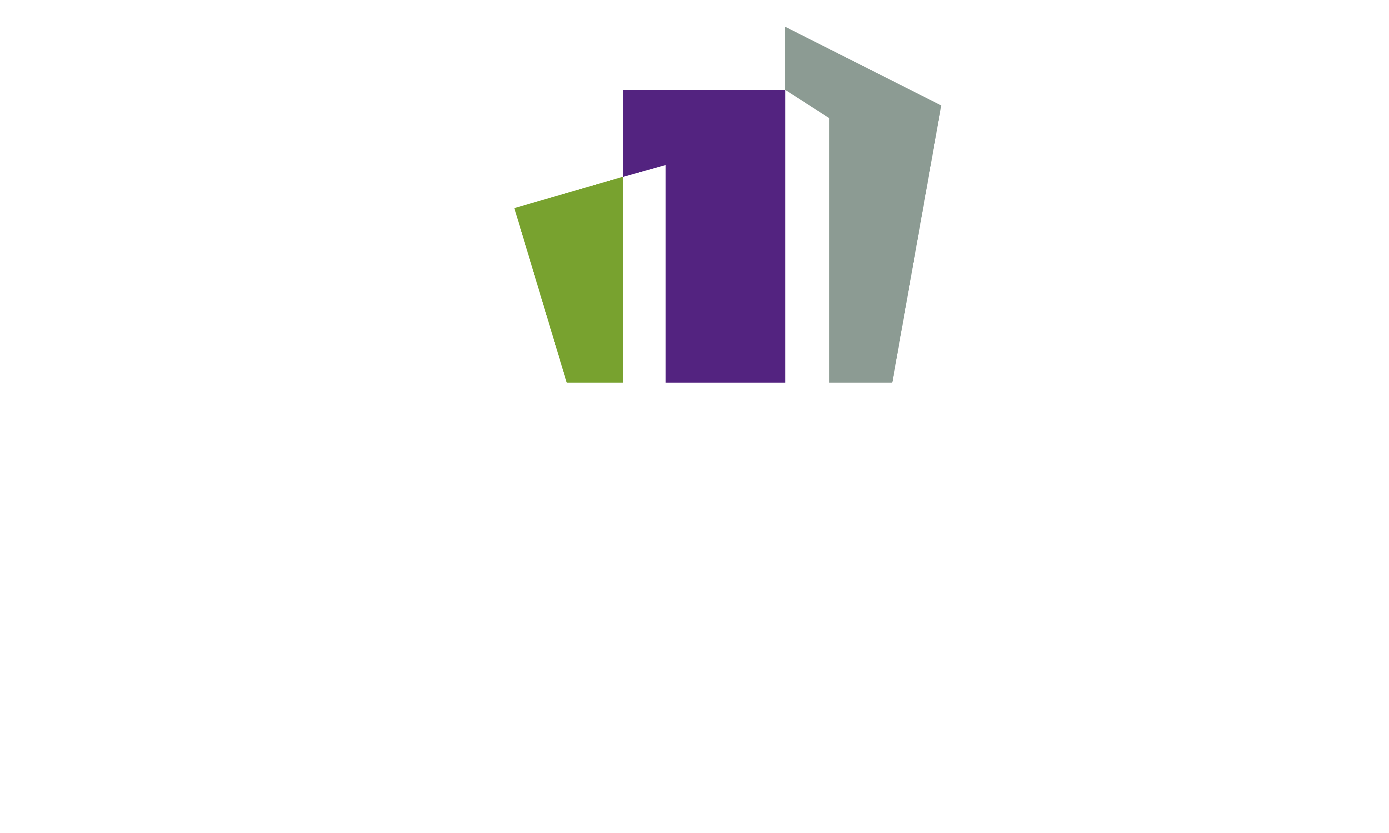

**Optimizing Relationships Between Marketing & IT**

* Revenue Recognition
* Savings
* Efficiency/Automation
* Self-service
* Guest Satisfaction
* Data Accuracy
* Compliance
* Preventative Maintenance
* Reductions of Defects

# **Introduction**

Friction has transpired in the relationship between Information Technology (IT) and commercial business units globally due to the complexity of marketing delivery and technology available in the marketplace and the process of introducing new technology into a company’s ecosystem. This breakdown of communication causes reduced performance visibility and an inability to execute commercial strategies, preventing many companies from expanding their presence across digital channels that are highly successful in other industries. HTNG and HSMAI teamed up to tackle this issue and provide guidance on how these teams can work more effectively together during the selection and integration of new digital products.

# **Deliverables**

The workgroup created several useful tools to aid in the onboarding of new digital marketing technologies.

* **Marketecture Diagram**

The team created an editable marketecture diagram to enable hotels to document all of their systems and their interactions with other systems along with who is responsible for the upkeep and ongoing maintenance of each system.

## **Workbook**

The workbook is your guide to assuring accountability for a successful installation and/or upgrade within your marketecture stack. Each tab provides direction and suggestions for ownership/responsibility with implementation. It is best to go through the tabs in order where you'll find instructions and guiding comments by hovering over certain areas within the workbook.

## **Glossary of Terms**

Although there are a number of glossaries publicly available for marketing nomenclature, a glossary is included that relates specifically to terms and how they are used throughout these documents.

# **Summary**

By utilizing these deliverables, organizations can navigate through their IT departments to advance business goals through digital transformation. This optimization will drive businesses forward in one or more of the following areas: