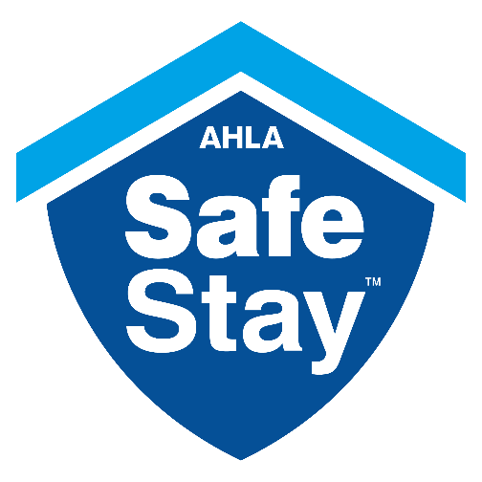

**Social for PSAs**

**Post 1**

Thanks to @AHLA’s #SafeStay standards, visitors to [STATE] will have peace of mind when it comes to traveling: [link to Safe Stay page]

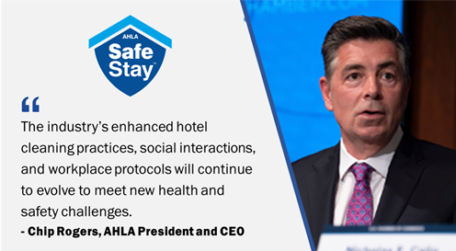

**Post 2**

[.@AHLA’s](mailto:.@AHLA’s) #SafeStay initiative helps ensure guests and employees are confident in the cleanliness and safety of [STATE] hotels once travel resumes. [https://www.usatoday.com/story/travel/hotels/2020/05/04/coronavirus-hotel-industry-issues-safety-guidelines-summer-travel/3074991001/](https://protect-us.mimecast.com/s/BpMWCNkjL5hlNpGcm0mBY?domain=usatoday.com)

**Post 3**

[PSA] is proud to join @AHLA’s #SafeStay initiative by enhancing hotel cleaning practices and workplace protocols to help guests and employees feel confident during post-pandemic travel: [https://www.ahla.com/safestay](https://protect-us.mimecast.com/s/3n0xCOYkM5URAkySvmPSb?domain=ahla.com)